**Final Homework**

Let’s say this is you first report on a new project. You should create real production report for business users, so follow all the best practices you know.

Using “data.xlsx” data create following pages:

# Milestones page

*Milestones page (No legend)*

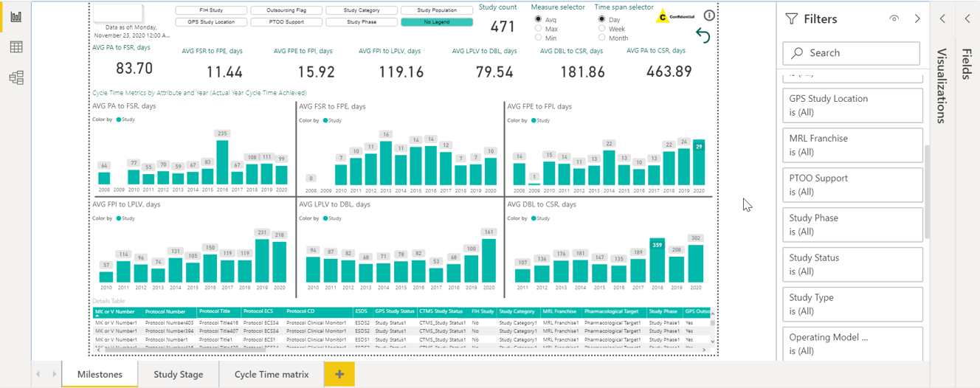

*Milestones page (FIH Study)*

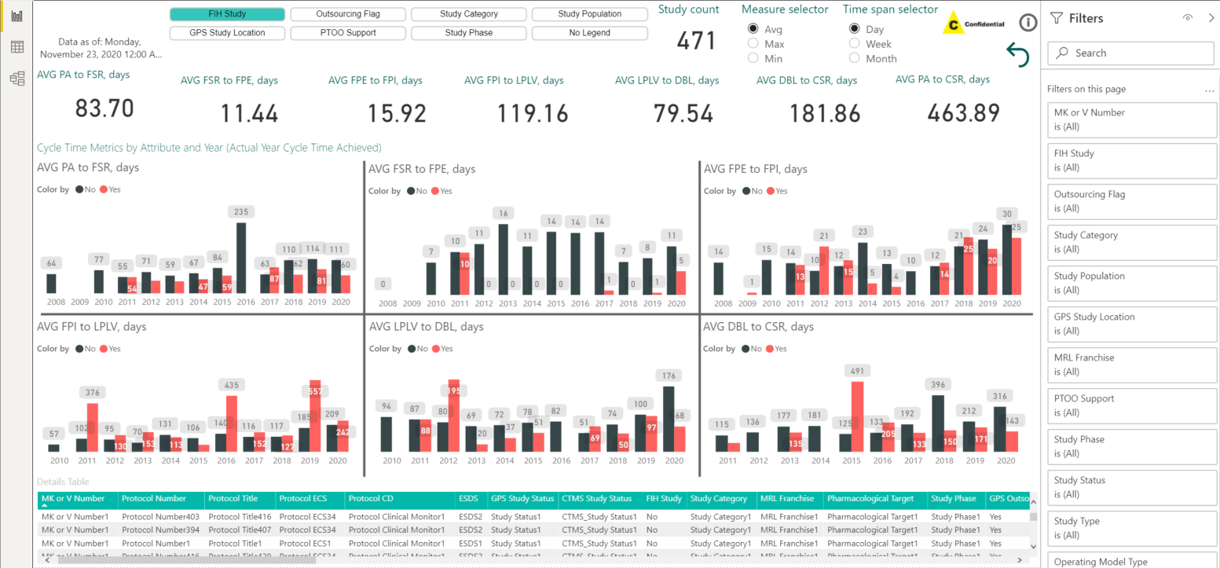

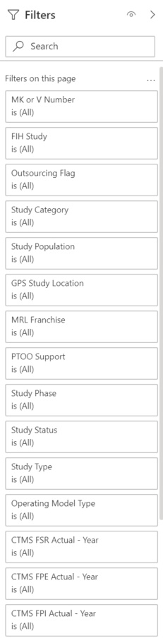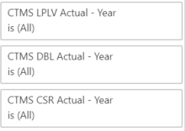

# Cycle Time matrix page

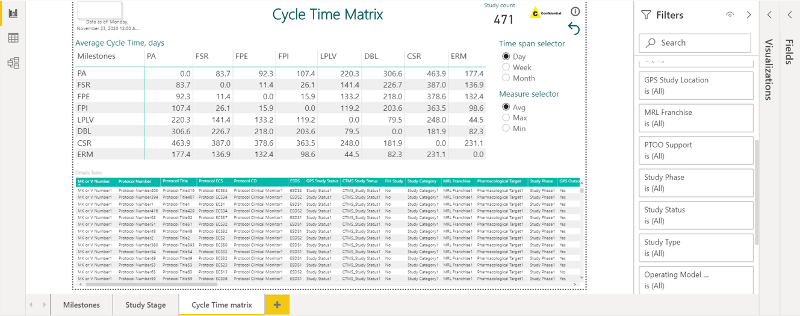

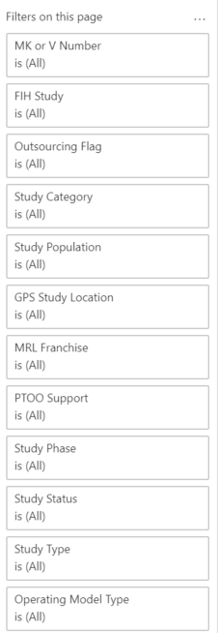

**Dataset description:**

The dataset is about clinical trials where PID is assigned to one study. Study has many different milestones from 2 different systems - GPS and CTMS. Also, study has many other non-date attributes. Cycle time is a difference between 2 milestones expressed in days/weeks/months.

**Here are general requirements:**

* Report should display consecutive cycle times for each **CTMS Actual** milestone.

*(Milestones page)*

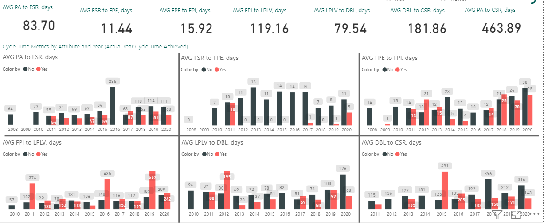

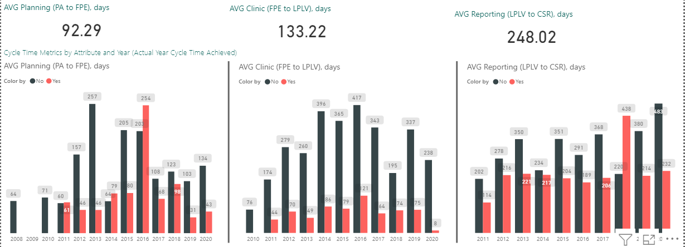

* Cycle time charts should have drill-down **Year-Quarter-Month** capability:

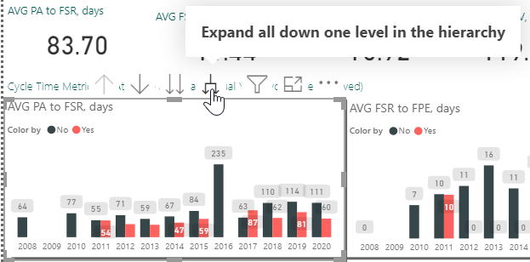

* Report should display cycle time from any milestone to any milestone. *(Cycle time matrix page)*

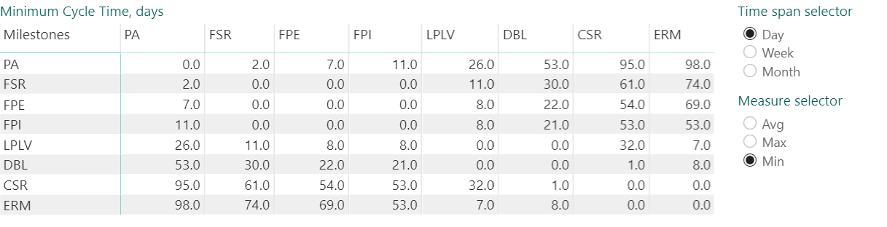

* Cycle times should be displayed with a legend or no legend - user should be able to choose what legend to use - FIH Study, Outsourcing Flag, Study Category, Study Population, GPS Study Location, PTOO Support, Study Phase or No Legend. Pay attention to categories order in the slicer.

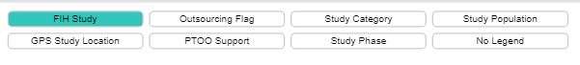

* User should be able to select aggregation for cycle times - avg, min or max.

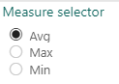

* User should be able to choose time span for cycle times - day, week, month. Months calculation should use days/30 rule and calculation for week should use days/7 rule.

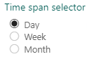

* Report should display general study count and detailed table.

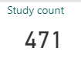



* Each report page should be marked as confidential and have a description.



Try to recreate report as close to mockups as you can and as many pages as you can. Keep in mind that users will work with this report, not just look at it as a picture.

* Use **CTMS Actual** milestones to calculate Cycle times.
* Calculate cycle time as **absolute value**
* Use **destination milestone for X axis**
* Use report state from mockups with *No legend* as default state (no filters in filter pane applied). The arrow 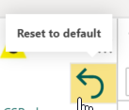 should reset state of the page to default.
* Here is the confidential logo: 
* Let information icon  show following text “This is information about … page” and insert page name.
* Below is information about custom visualization “Chiclet Slicer”:





Fields for “Details Table”:

* MK or V Number
* Protocol Number
* Protocol Title
* Protocol ECS
* Protocol CD (use Protocol Clinical Monitor field)
* ESDS
* GPS Study Status (use Study Status field)
* CTMS Study Status
* FIH Study
* Study Category
* MRL Franchise
* Pharmacological Target
* Study Phase
* GPS Outsourcing Flag (use Outsourcing Flag field)
* Operating Model Type
* PTOO Support
* Study Population
* GPS Study Location (use Site field)
* CTMS Country (use CTMS Study Location field)
* Final Site Selected
* Final Site Selected - Other (use Final Selected Site Comments field)
* GPS PA Planned
* GPS PA Actual​
* GPS FSR Planned​
* GPS FSR Actual​
* GPS FPE Planned​
* GPS FPE Actual​
* GPS LPLV Planned​
* GPS LPLV Actual​
* GPS DBL Planned​
* GPS DBL Actual​
* GPS CSR Planned​
* GPS CSR Actual​
* GPS ERM Planned​
* GPS ERM Actual​
* CTMS PA Planned
* CTMS PA Actual
* CTMS FSR Planned
* CTMS FSR Actual
* CTMS FPE Planned
* CTMS FPE Actual
* CTMS FPI Planned
* CTMS FPI Actual
* CTMS LPLV Planned
* CTMS LPLV Actual
* CTMS DBL Planned
* CTMS DBL Actual
* CTMS CSR Planned
* CTMS CSR Actual